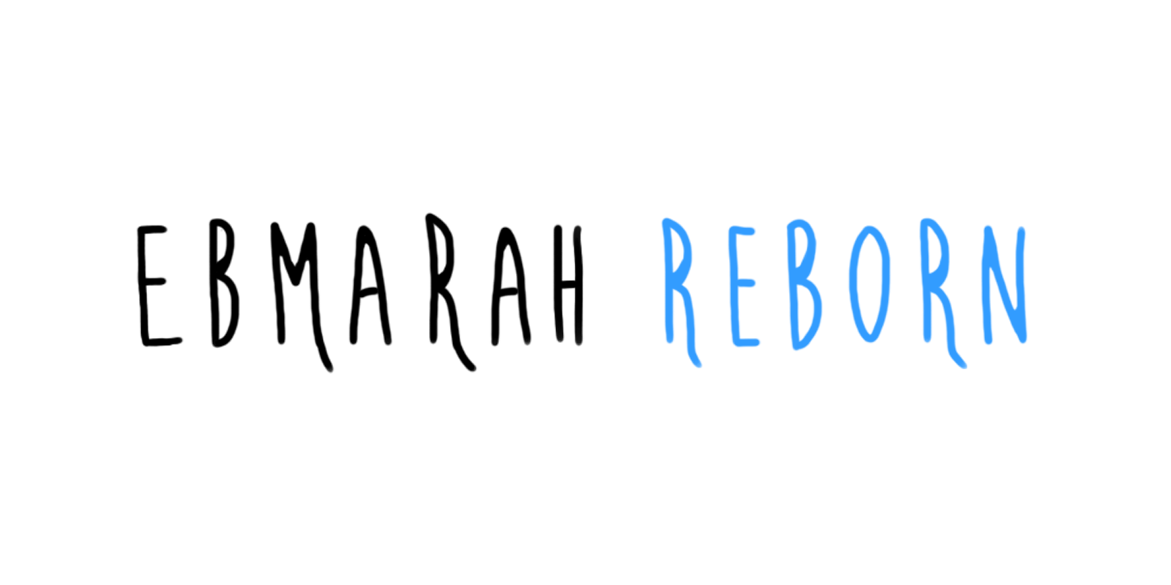

Game Design Document
  - One Game Studio
  - Version 2.0

Position Title | Name | Signature
Assistant Lead/Level Designer | Justin Loar
Asst. Game Designer/Level Designer | Chris Coyne
Artist | Sarah Broussard
Programmer | Dharmik Dave

Document Revisions Table
Version | Description | Requestor | Date
1.0 | Initial Document | Ouellette, Despain | 9/29/2016
1.1 | Revised entire document to reflect a change in direction to fast-paced platform/puzzle play design, updated concept art. Cut tree objects from the design. Added Level Details section. Revised based on comments by Ouellette. | Ouellette, Despain, Fisher, Stringer | 10/30/2016
1.2 | Updated the Menu Flow diagram | Justin Loar, Chris Coyne | 11/5/2016
2.0 | Updated entire document per feedback | Fisher, Ouellette, Despain, Stringer | 12/10/2016

Table of Contents
Camera/HUD 4
Controls 5
Game Metrics 6
Communication/Conveyance Mechanisms 6
Player Movement/Interactions 8
Health System/Checkpoint System 11
Enemies 12
Enemy Movement/Interactions 12
Objects System 14
Pickups System 14
World Layout 16
Game World Overview 16
Menu System 17
Menu Flow 17
Menu Descriptions 17
Menu Details 18
Installation 18
Title Splash Screen(s) 18
Main Menu 18
Options/Controls Screen 19
Credits Screen 19
Exit/Pause Screen 20
Game Over Screens 20
Credits 21

Camera/HUD
Figure 5: The main character and environment of Ebmarah Reborn. [1]
HUD Item | Description
Pause Button | Pauses the game, bring up options menu
Health Bar | Conveys the player’s health out of 5 units
Progress Bar | Displays the player’s progress through the level, fills up as the player progresses
Collectible Counter | Displays the number of collectibles the player has picked up out of the total number of collectibles in the level

The camera follows the player only on the x-axis. The camera is locked on the y-axis and does not track vertical movement. There is a minimal Heads Up Display (HUD) that includes a pause button and the number of items the player has collected. Interactive elements, such as rocks that the player can push or trees that the player can shoot, glow white. See Communication/Conveyance Mechanisms for how to determine player health.

Controls
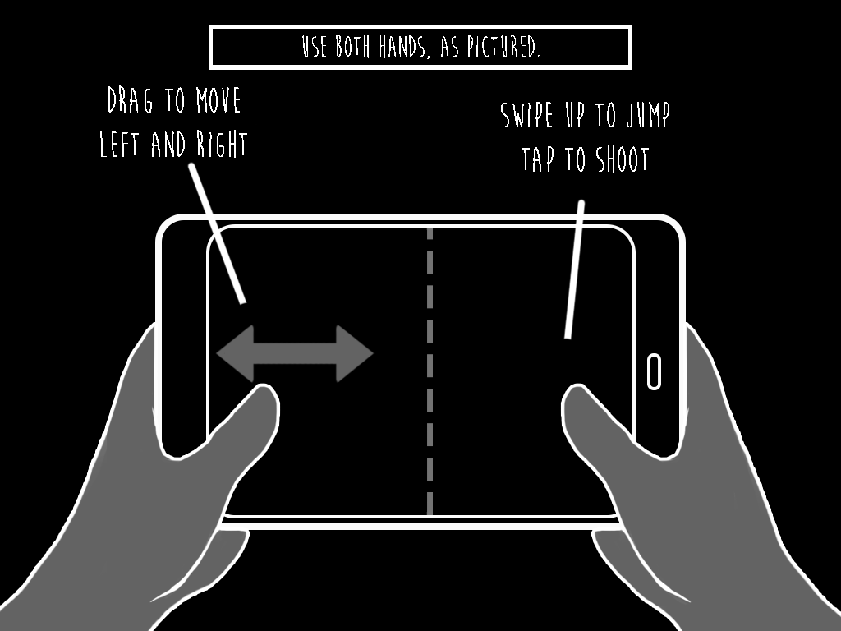
Figure 6: Diagram of Controls [1]
The player moves left and right by dragging their left thumb horizontally. Dragging to the left makes the character run left, and dragging to the right makes the character run right. The player continues to move until they release their thumb. The player jumps by swiping upwards with their right thumb. The player shoots by tapping the screen.
The controls screen is automatically displayed at the beginning of Tutorial 1 and Tutorial 2. The player cannot shoot in Tutorial 1, so the Controls screen does not tell the player that they can shoot until the Controls screen on Tutorial 2. The full controls are available in the pause menu and the options from the start screen. For more information, see Menu Details.

Game Metrics
Item | Description
Player Size | 1.28 units
Maximum Player Speed | 5 units per second
Maximum Jump Height | 3.8 units
Jump Speed | 30 units per second
Spirit Ball Speed | 7 units per second
Player Health | 5 units
Player Lives | Infinite
Object Push Speed | 2.5 units per second
Enemy Height | 1.28 units
Enemy Speed | 3 units per second
Enemy Damage | 1 unit
Enemy Health | 1 unit
Flying Enemy Attack Rate | 1.33 attacks per second (one attack every 0.75s)

Communication/Conveyance Mechanisms
Player Health: The player’s health is indicated in the upper left corner of the screen right of the pause button, it is displayed as five white leaves on a branch. Each time the player touches a hazard or touched by enemy body/projectile, the player flashes red and plays hurt animation as leaf disappears from the branch. To regain health green drops can be picked up, this places another leaf on the branch to a cap of 5 leaves. If the player reaches zero leaves the player is considered “dead” and will play a death animation. After death, the player either respawns at full health to the last reached checkpoint or beginning of level at full health if a checkpoint has not been reached.
Figure 7: Player health bar at every state from zero health to full health [1]

Platforms: The player can walk on any surface with light green grass. The player can enter caves, which all feature a yellow glowing background. The player can jump through all platforms except through the ceilings of caves. The player can never pass dark gray rocks (unmovable rocks) covered in grass, which all look similar.
Figure 8: Platform conveyance system [1]

Interactable items: All interactable items glow with a color that represents their significance to the game. Enemies and hazards glow red, health glows green, and puzzle elements (rocks and collectible items) glow white. Only interactable items glow. The player also has a white glow, so the player sees a connection between their character and things they can interact with.
Figure 9: Interactable objects [1]

Player Movement/Interactions
- Run left and right
- Jump
  - Jump from idle or from running
  - Jump between platforms
  - Jump over hazards
  - Jump over enemies
  - Jump over rocks to push from a different direction
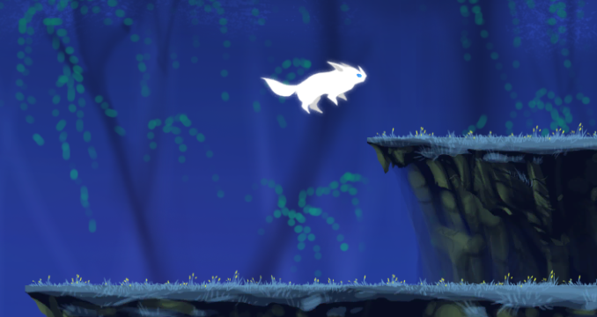
Figure 10: Character jumping [1]

- Enemies
  - Shooting an enemy once kills it.
  - Shooting ground enemy from the front does not do damage, player must jump over or attack from behind to kill it.
  - Touching an enemy or an enemy projectile does 1 damage to the player.
  - When the player is hurt, they flash red, play a hurt animation.
  - Flying Enemies start shooting projectiles when the player is within its range.
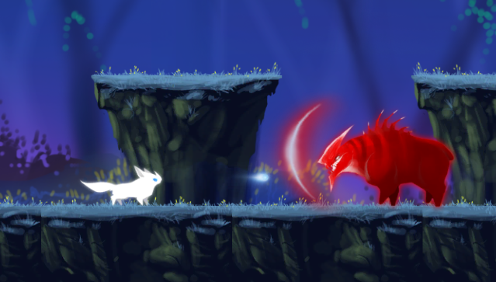
Figure 11: Player attacking a ground enemy from the front [1]
- Hazards
  - Touching a hazard does 1 damage to the player.
  - Hazards are indestructible.
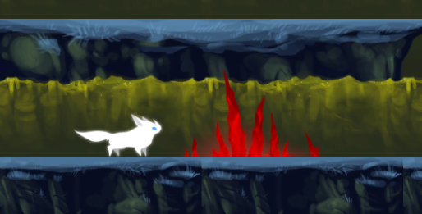
Figure 12: Spike hazard [1]

- Push rocks
  - Fill gaps in platforms
  - Solve puzzles
Figure 13: Player pushing a rock [1]
- Collect items
  - Health pickup (green) restores 1 health to the player.
  - Collectible item (blue & white) adds 1 to the player inventory.
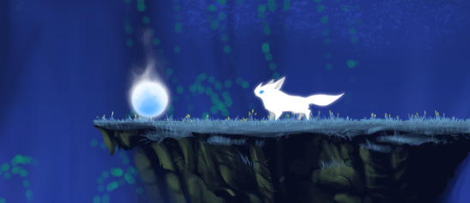
Figure 14: Collectible item [1]
- Death
  - When the player loses all their health, the character plays a death animation. They are regenerated at their last checkpoint.
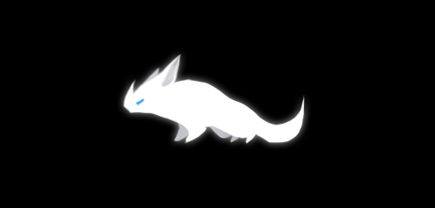
Figure 15: Player death [1]

Health System/Checkpoint System
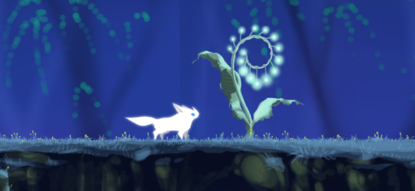
Figure 16: Player at a checkpoint [1]
The player takes damage from hazards and evil spirits. Ground enemies lower the player’s health by one unit by colliding with the player. Flying enemies can also lower the player’s health by one unit by shooting projectiles that collide with the player. A green health pickup regenerates the player’s health. For each health pick up the player collects, one white leaf to the health bar is added.
If the player crosses a checkpoint and dies, they are respawned at the last checkpoint. The checkpoint progress does not save if the player closes the application.

Enemies
Figure 22: Ground enemy and flying enemy [1]
The enemies in this game are dark spirits. Their ideologies and attitude towards the weak has resulted in them having an evil nature. They want to impede Ebmarah’s progress and trap her in the Afterworld.
Flying enemy | Damage | 1
Flying enemy | Speed | 3 units per second
Flying enemy | Special characteristic(s) | Flying: Levitates off the ground  Projectile: Shoots projectiles in a straight line when near the player (1 damage, 3 units per second speed)
Flying enemy | Special characteristic(s) | Projectile: Shoots projectiles in a straight line when near the player (1 damage, 3 units per second speed)
Ground enemy | Damage | 1
Ground enemy | Speed | 3 units per second
Ground enemy | Special characteristic(s) | Shield: Cannot be attacked from the front

Enemy Movement/Interactions
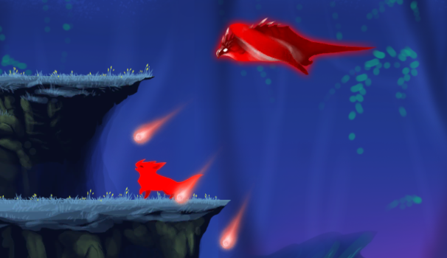
Figure 26: Flying enemy attacking the player [1]
Flying enemies move left and right in the air floating above the platforms. They shoot three projectiles in a fan at a 45-degree angle downward towards the player when they are in line of sight with the player, determined by collision triggers. These projectiles end on world collision. These enemies do not have shields, and can be defeated by player projectiles.
Figure 27: Player attacking a ground enemy from the front [1]
Ground enemies move back and forth on their platform and cannot jump from platform to platform. Enemies hurt the player on touch. Ground enemies have a front-facing shield, preventing the player from shooting them head-on. The player must shoot ground enemies from behind.

Objects System
Figure 28: Player pushing a rock [1]
Table 1: Objects in Ebmarah Reborn
Object | Description
Large Rock | Large rocks block the player’s path along optional routes. Players can push rocks into adjacent holes to clear a path for the player to reach optional objectives (e.g. hidden collectibles, alternate paths).

Pickups System
Figure 29: Pickup items [1]
Table 2: Pickups in Ebmarah Reborn
Pickup | Description
Health Spirit (Health) | Enemies drop green Health Spirits on defeat. These regenerate 1 unit of player health on pickup.
Life Fiber (Collectible) | Life Fiber can be found hidden in each level. These are collectibles limited to 10 in each level. This collectible is one metric of player success, and encourages the player to explore the entire area, not just the most efficient path. By design, this brings the player into more encounters with enemies, through more difficult jumping puzzles, and encourage players to think laterally about how they navigate levels.

World Layout

Game World Overview
Figure 30: Game World Overview [1]
Tutorial 1 takes place in a bright and blooming green forest. The player runs and jumps through the environment without any enemies. This area is very easy and gives the player time to familiarize themselves with the controls of the game. The level concludes with the player trying to jump across a large impossible gap, failing, and the game fades to white. This represents the character dying and transitioning to the Afterworld.
Tutorial 2 transitions the player into an eerie dark spirit version of the same level. This level is a carbon copy of Tutorial 1 with a new art theme and enemies added to it. The player encounters one flying enemy and one ground enemy to familiarize them with the unique challenges of each. The player encounters one rock that they must push to continue, which leads them to a single collectible. By the end of this level, the player has encountered all the tools they must use and types of obstacles they must overcome throughout the game. The level concludes with the player reaching a large checkpoint and the camera fades to black.
Level One takes place in the same fantasy-type spirit forest area. This level is much longer than the tutorial levels. The player encounters many enemies and obstacles, but the difficulty is still relatively low. The player can traverse optional areas and collect several pickup collectibles. The level concludes with the player reaching a large checkpoint and the camera fades to black.
Level Two contains the same environment as the previous Level One. The player must traverse a much more difficult level with more dangerous enemy encounters and difficult platforming. The player encounters a few areas where the path diverges and gives the player alternate paths through the space. More dangerous alternatives are also the most rewarding, and give the player more collectible items. The level concludes with the player reaching their living body from the beginning. The camera fades to black.
The end screen shows the player character, having risen from the dead, back in the living world from the beginning of the game. The area is small, but the player can run and jump around. This screen thanks the player and displays credits. The player can return to the main menu from this screen.

Menu System

Menu Flow
Figure 33: Menu flowchart [3]

Menu Descriptions
Table 4: Menu Descriptions
Menu | Selection Items | Content
Main Menu | - Play  - Options  - Credits | - This menu loads after the splash pages.  - “Play” takes the player to the Diagram of Controls and then the first level.  - “Options” takes the player to the Options menu.
Options | - Sound On/Off  - Controls  - Back | - “Sound On/Off” toggles the background music and sound effects on and off.  - “Controls” takes players to the Diagram of Controls.  - “Back” takes the player to the main menu.
Pause Menu | - Sound On/Off  - Controls  - Resume  - Main Menu | - The pause menu displays buttons to resume, go to main menu and a toggle for sound.  - “Sound On/Off” toggles the background music and sound effects on and off.  - “Controls” takes players to the Diagram of Controls.  - “Resume” takes the player back to the game.  - “Main Menu” takes the player back to the main (start) screen.

Menu Details

Installation
The player downloads the game’s apk file and installs it on their Android device. After the player installs the game, the player sees an icon of the game’s logo with the game’s name underneath. Clicking this icon loads the game.

Title Splash Screen(s)
- Unity Splash
- Guildhall Splash

Main Menu
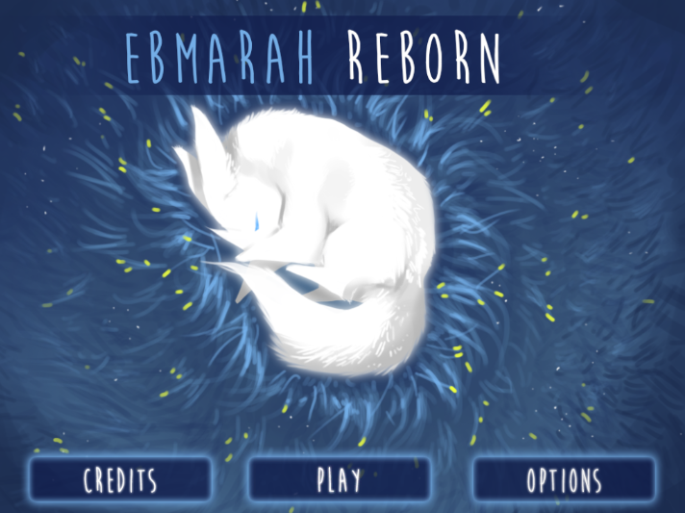
Figure 34: Start menu
- Play
  - Starts the game. Takes the player to Tutorial 1.
- Options
  - Takes the player to the Options/Controls Screen.
- Credits
  - Takes the player to the Credits Screen.

Options/Controls Screen
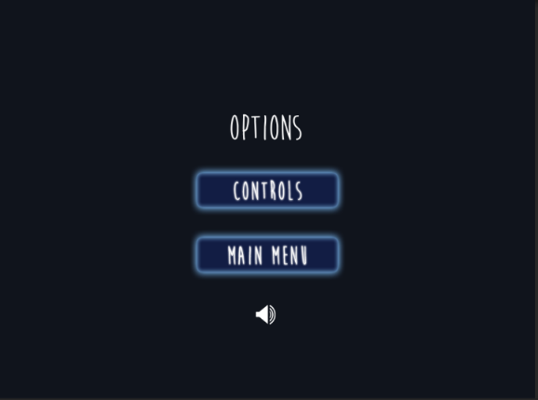
Figure 35: Options menu
- Sound On/Off
  - Toggle switch that turns all the sound in the game on and off (default is on).
- Controls
  - Takes the player to the Diagram of Controls.
- Resume
  - Resumes the game.
- Main Menu
  - Takes the player back to the main menu.

Credits Screen
- Executive Producer: Boris Fisher
- Assistant Team Lead/Level Designer: Justin Loar
- Assistant Game Designer/Level Designer: Chris Coyne
- Programmer: Dharmik Dave
- Artist: Sarah Broussard
- Music and font credits.
- Back button takes players to the Main Menu.

Exit/Pause Screen
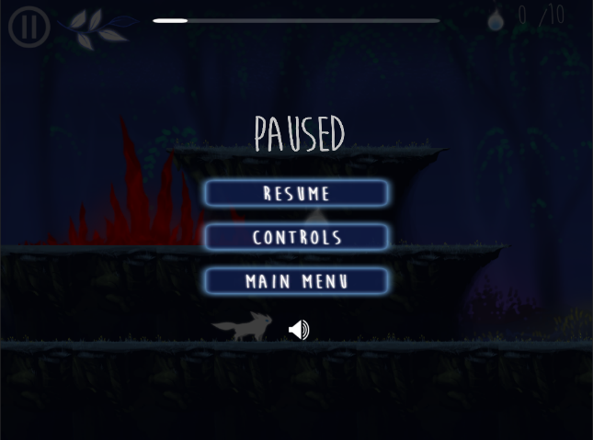
Figure 36: Pause menu
The player can access the pause screen at any time during play, which includes the following:
- Sound On/Off
  - Toggle switch that turns all the sound in the game on and off (default is on).
- Controls
  - Takes the player to the Diagram of Controls.
- Resume
  - Resumes the game.
- Main Menu
  - Takes the player back to the main menu.

Game Over Screens
The Game Over screen plays on game completion. This screen thanks the player, displays credits, and has the option to Exit to Main Menu. The player can also play with the character on the game over screen.

Credits
[1] Sarah Broussard
[2] Justin Loar
[3] Chris Coyne

